第一章 函数极限与连续

1000B

知识点：

麦克劳林展开：
https://chatgpt.com/g/g-p-6a1d505226e08191a7f47eb8e9418ffe-gao-shu-ocr/c/6a714a91-f9d4-83ee-b119-79805f773f0f
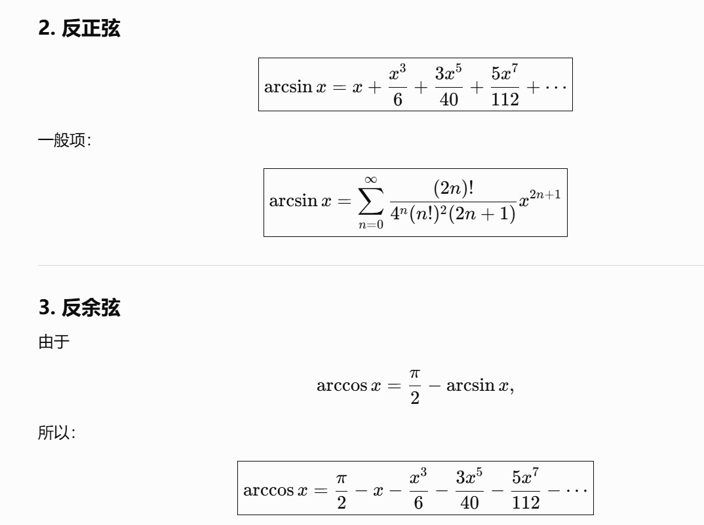
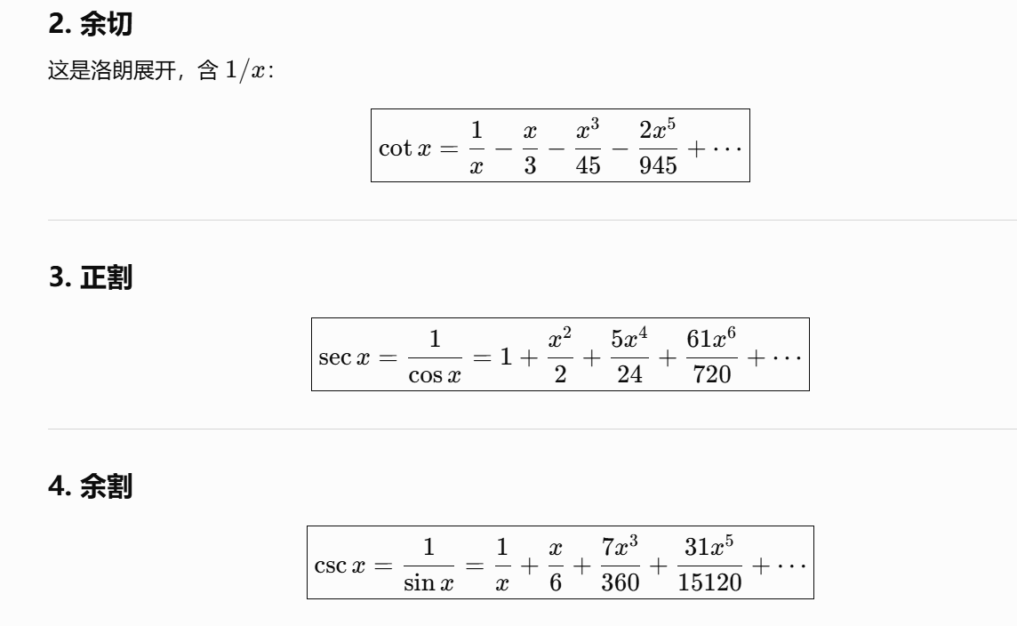
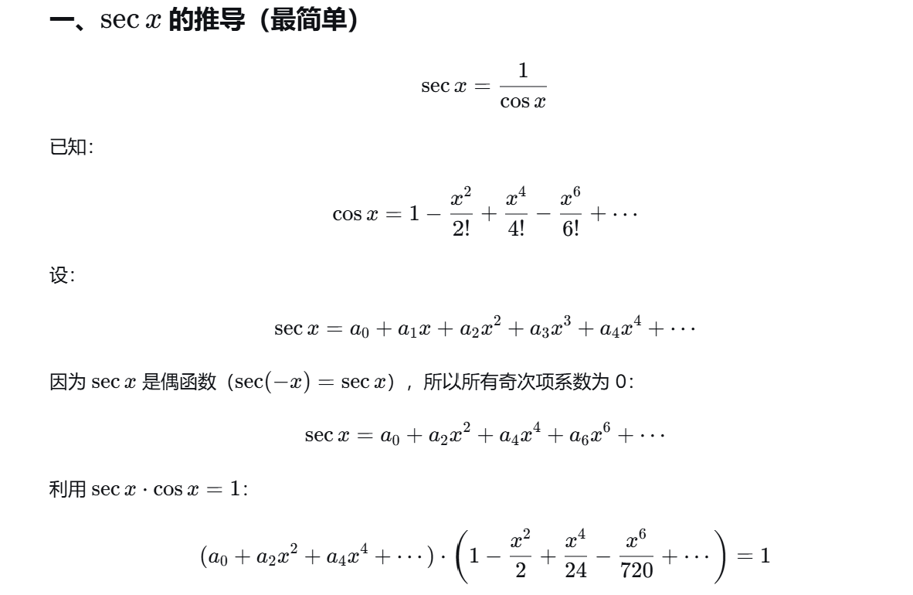
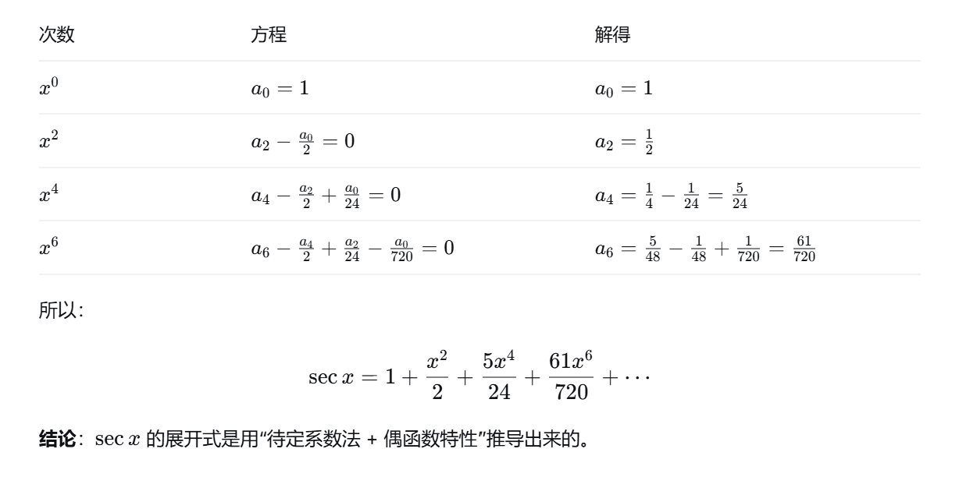
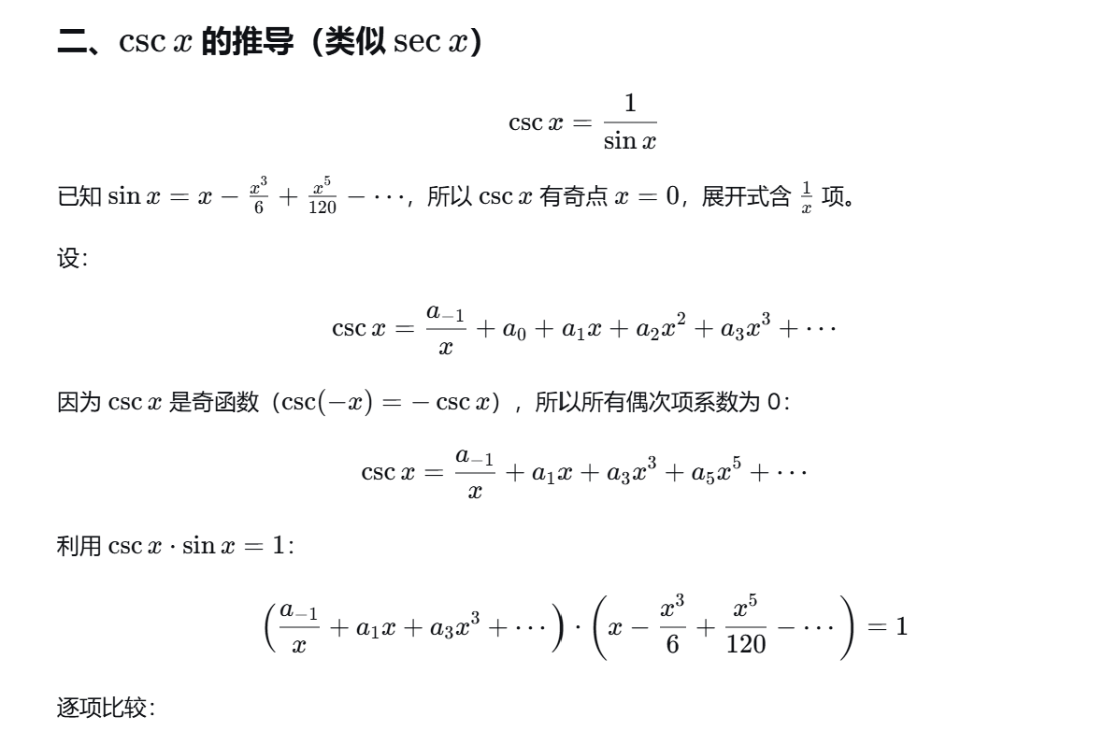
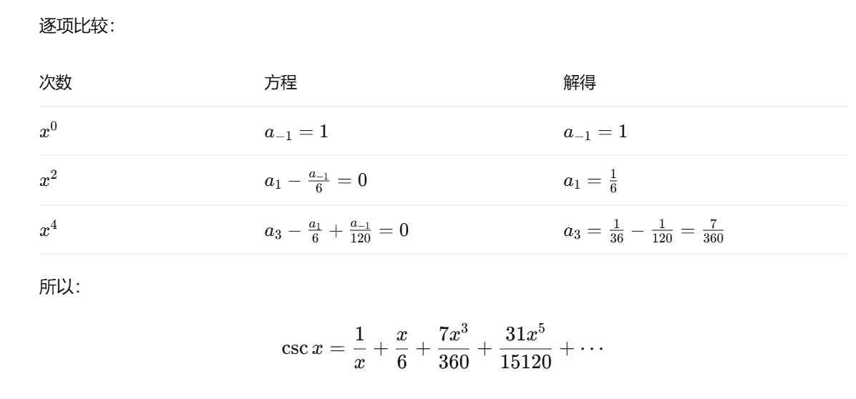
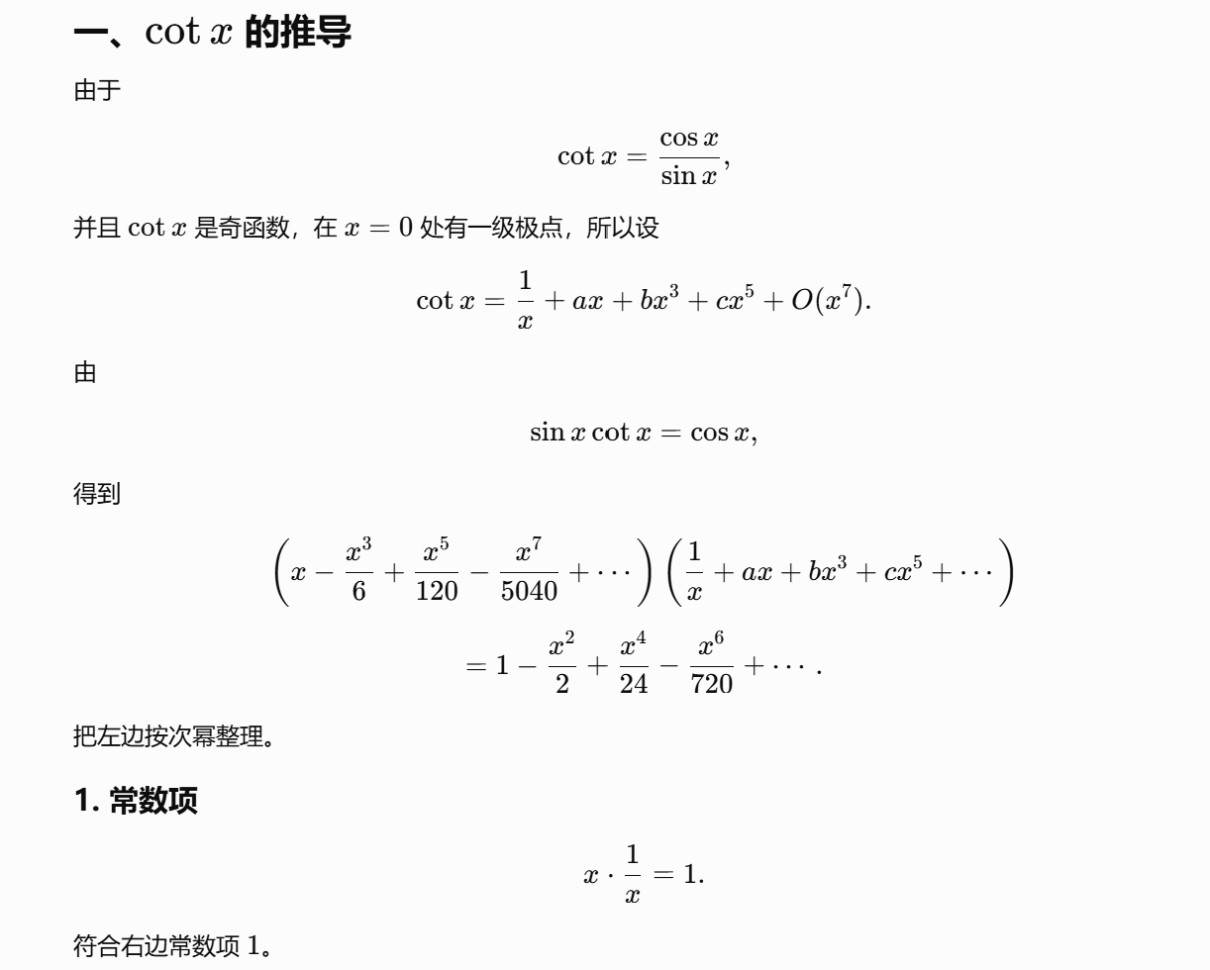
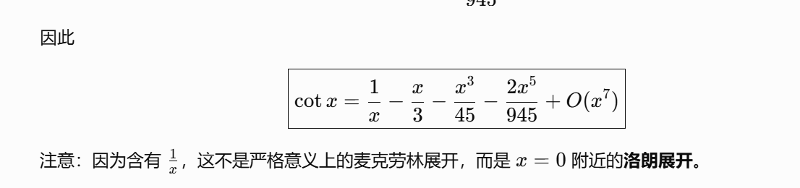
https://chatgpt.com/c/6a714e0b-ac44-83ee-83df-e05500d24449

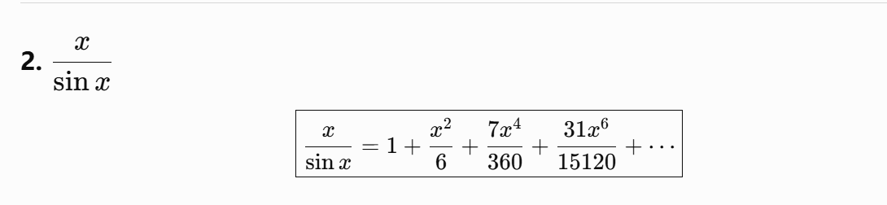
https://chatgpt.com/c/6a714fcb-10b0-83e8-8dfb-e325aba0e77f

Leibniz公式：
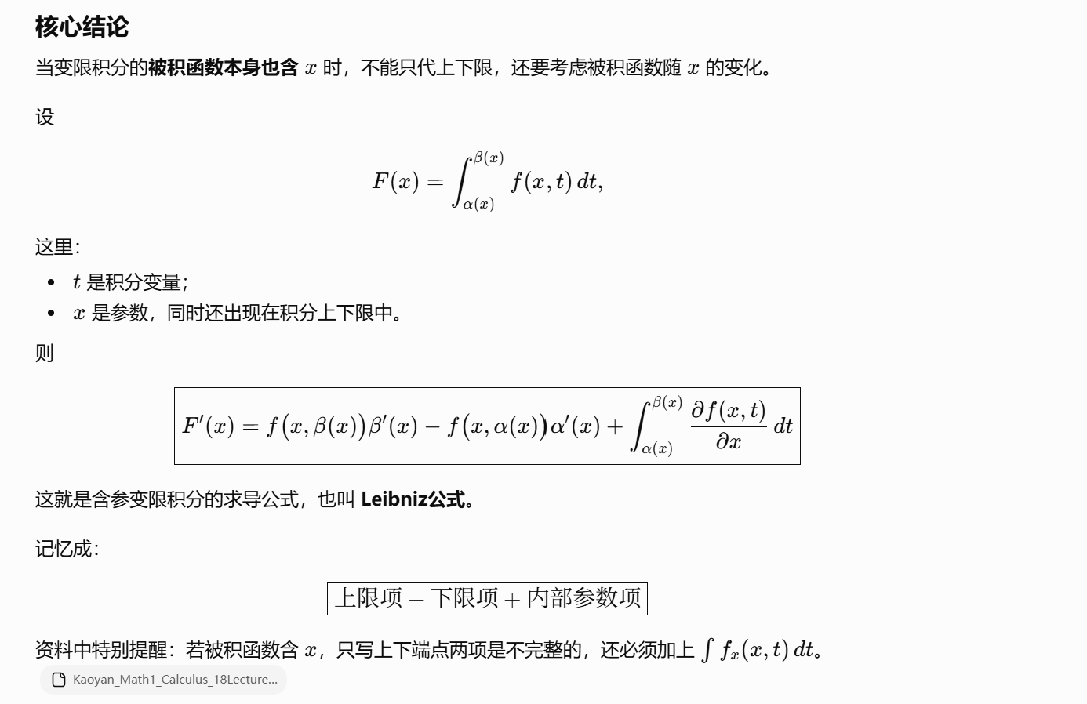

积分中的等价替换：
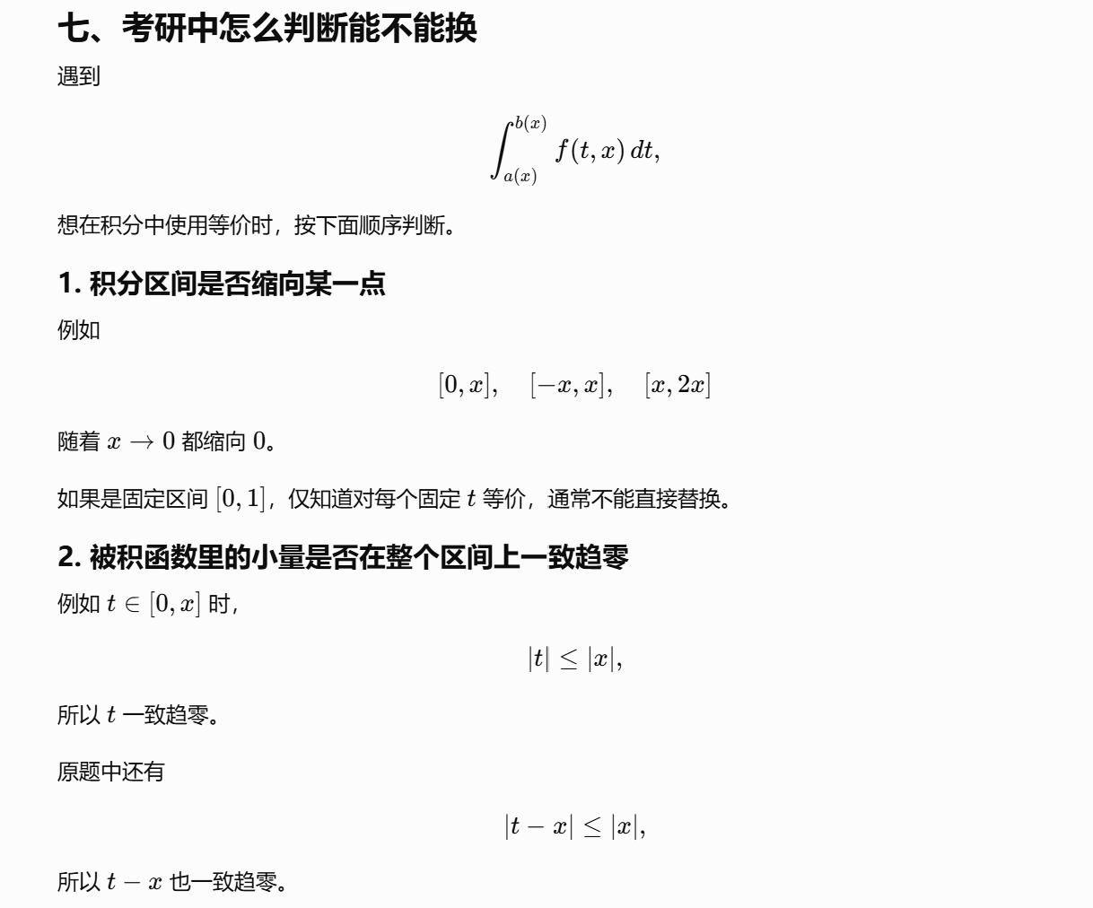
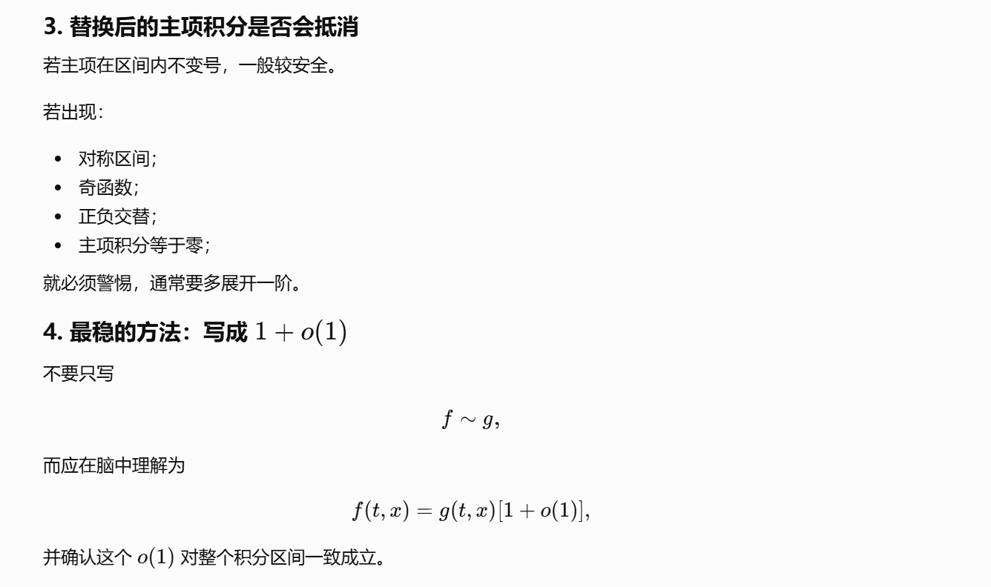

题：

题1：

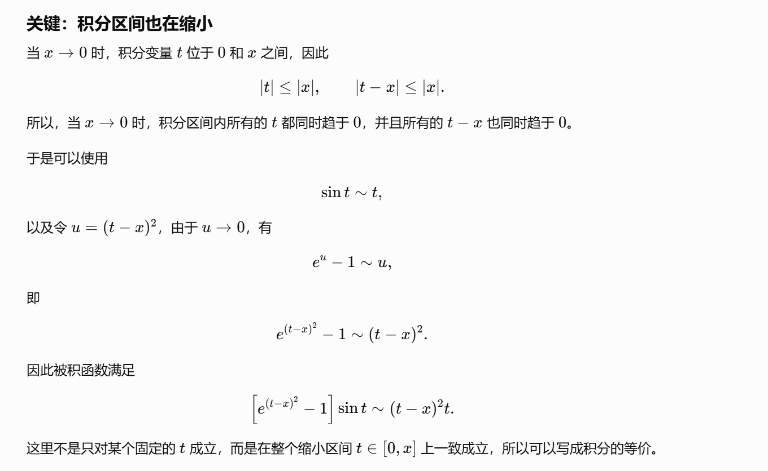
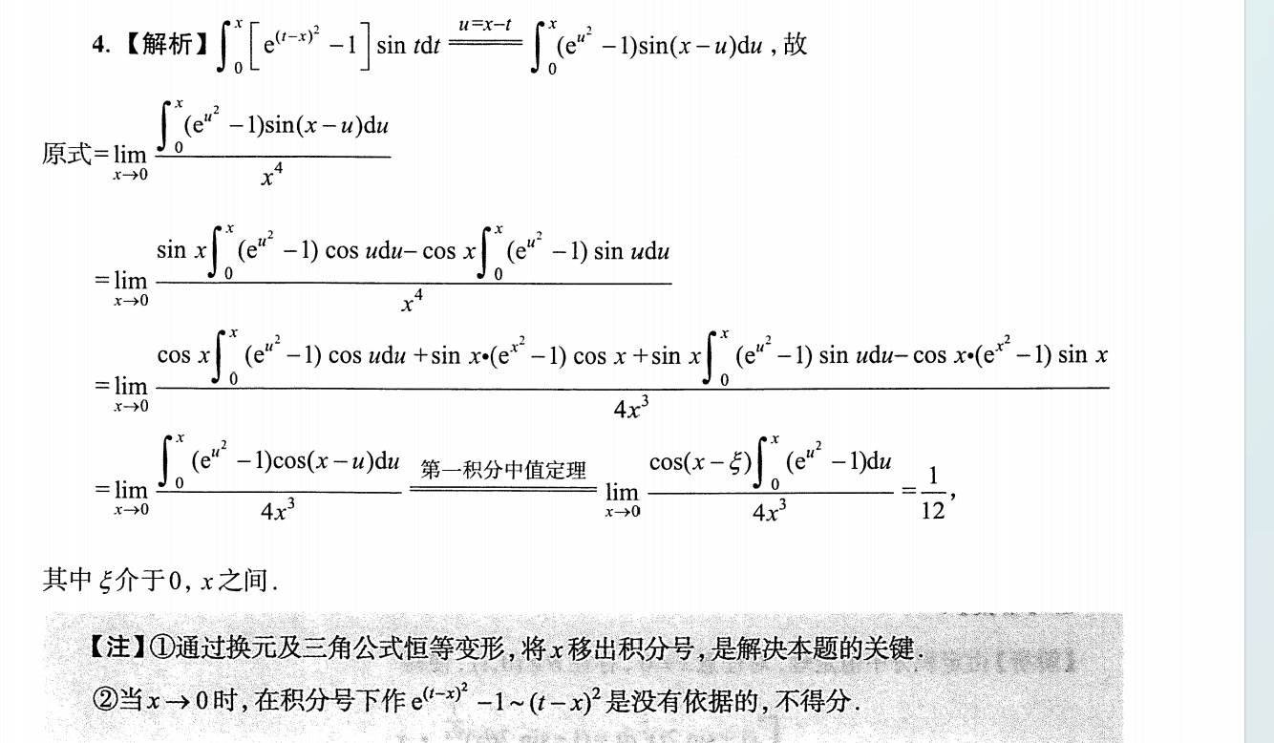
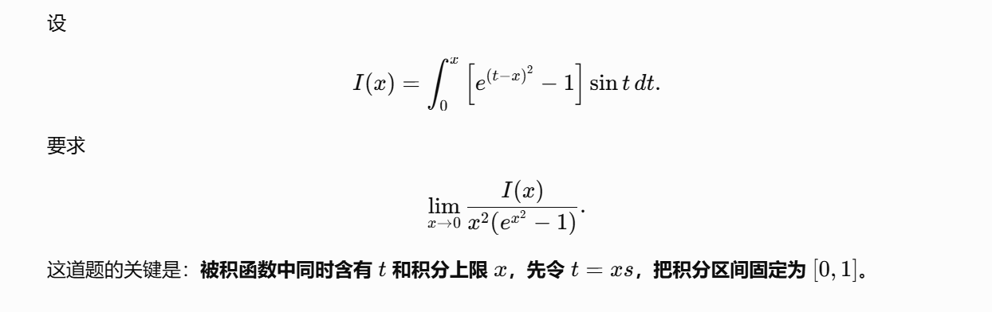
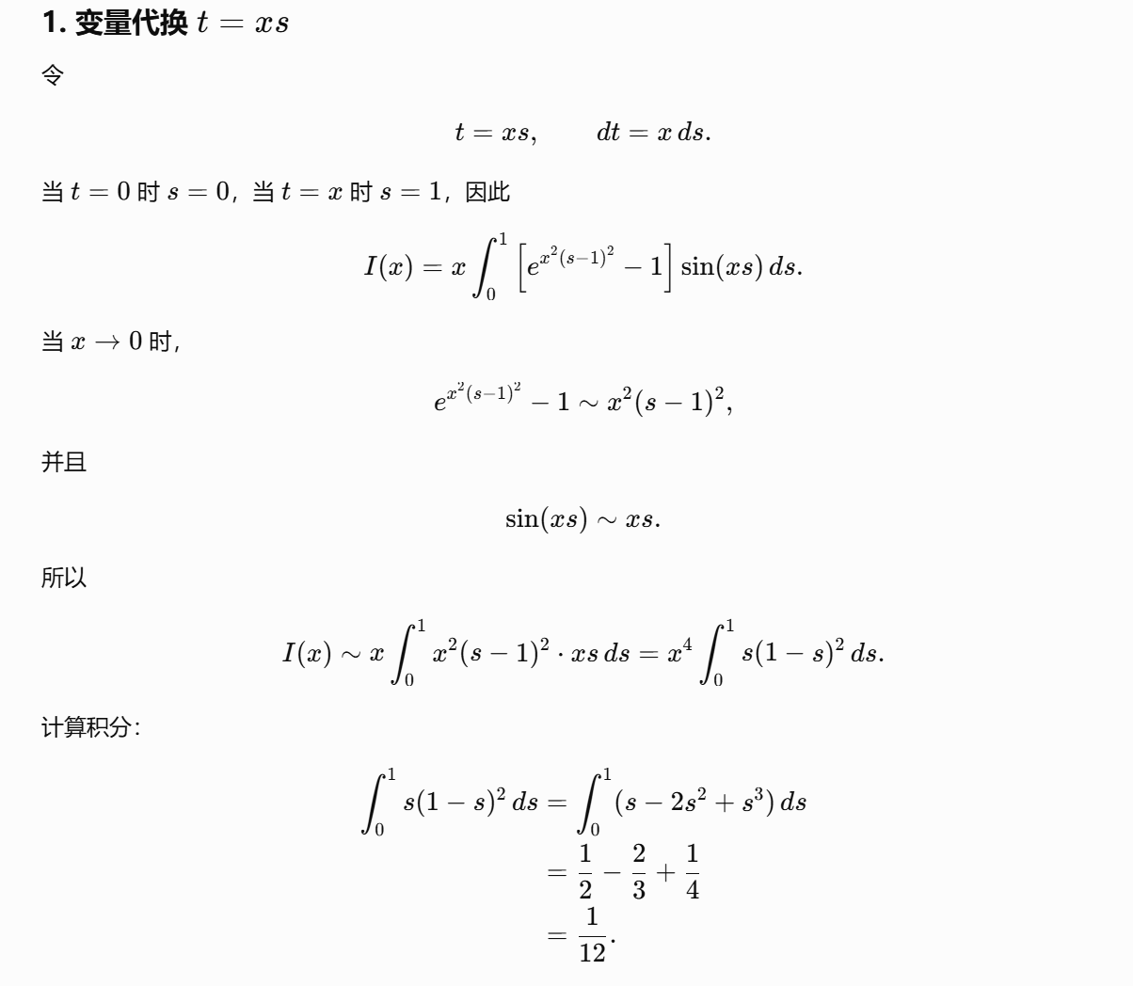
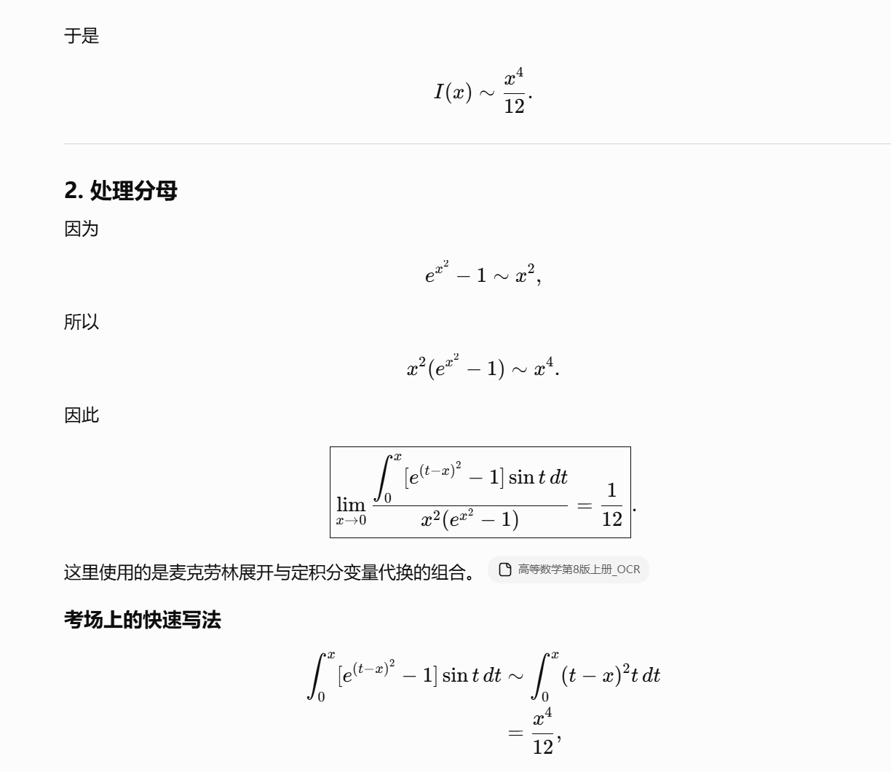
https://chatgpt.com/g/g-p-6a1d505226e08191a7f47eb8e9418ffe-gao-shu-ocr/c/6a71647c-0e44-83ee-86c2-ce1c7854e330

题2：
https://chatgpt.com/c/6a757da8-bbd8-83ee-aef0-df0b7939561c
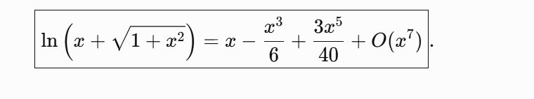
https://chatgpt.com/g/g-p-6a1d505226e08191a7f47eb8e9418ffe-gao-shu-ocr/c/6a76cfc4-2adc-83ee-a6a9-9e1e171988fe

题3：
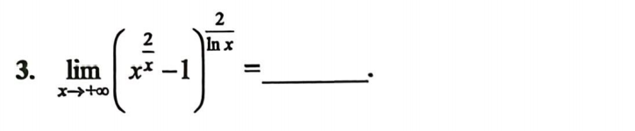
https://chatgpt.com/g/g-p-6a1d505226e08191a7f47eb8e9418ffe-gao-shu-ocr/c/6a76cd16-7e2c-83e8-ad38-c3d68a293dd0

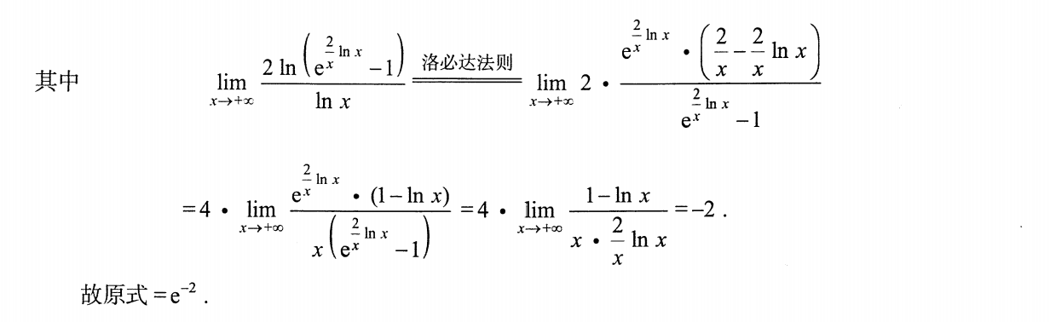

题4：
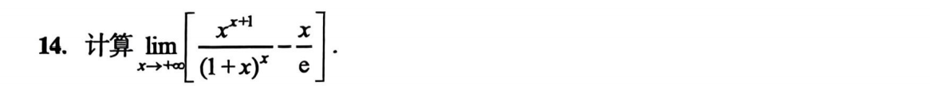
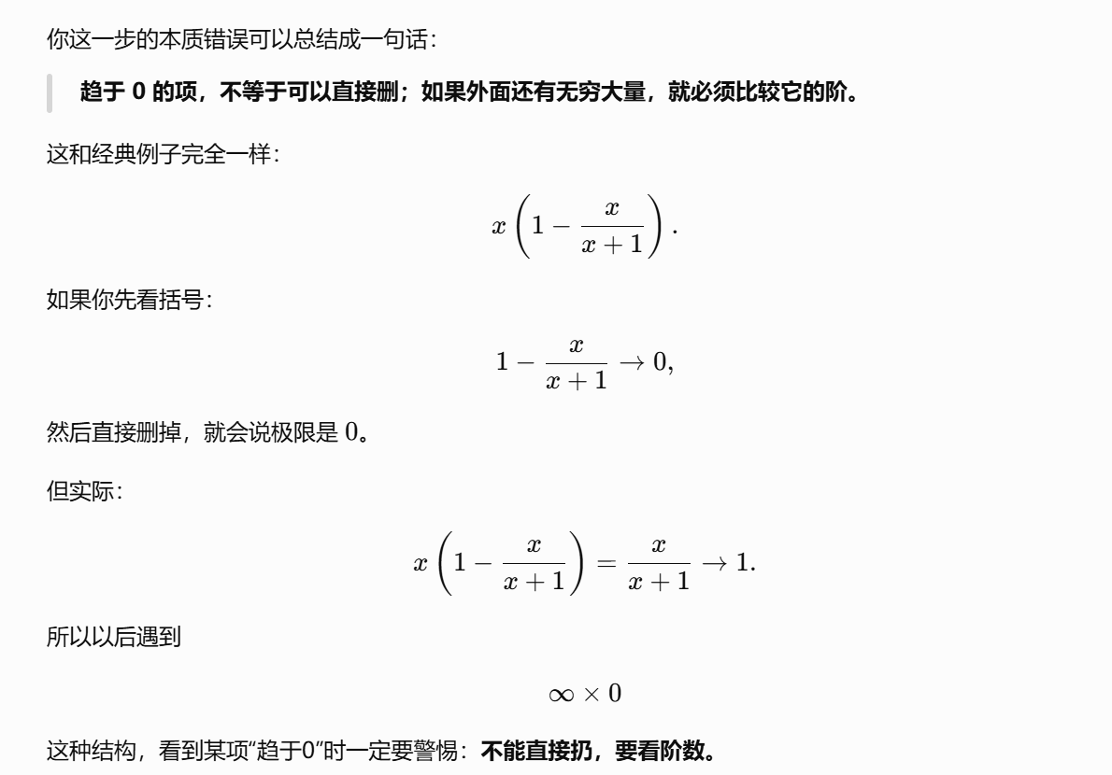
https://chatgpt.com/g/g-p-6a1d505226e08191a7f47eb8e9418ffe-gao-shu-ocr/c/6a76d0ec-6e78-83ee-850f-bc27b55cd595

题5：
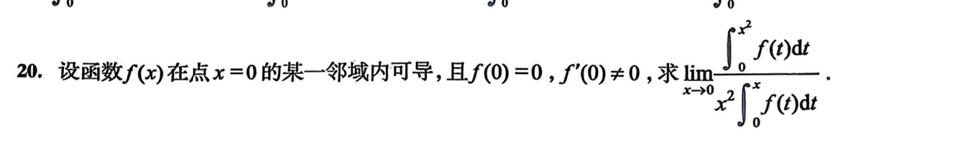
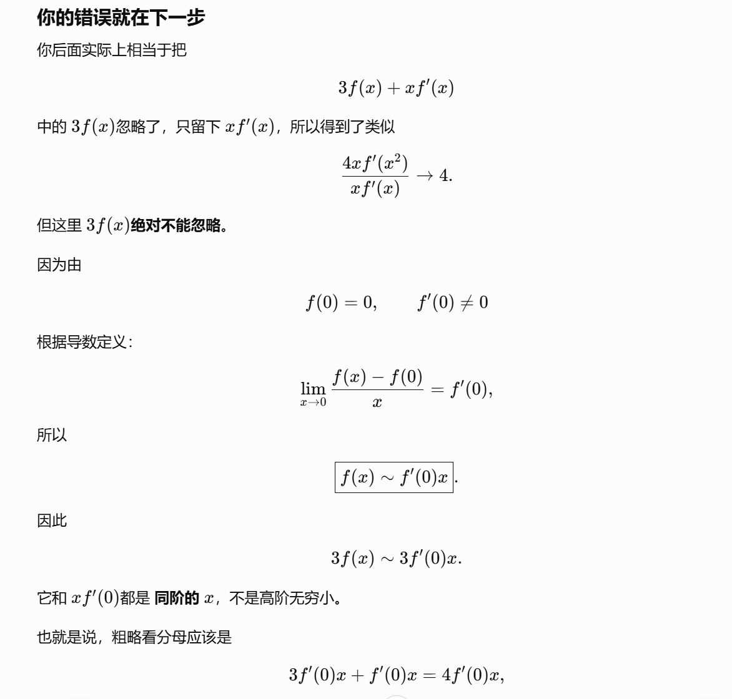
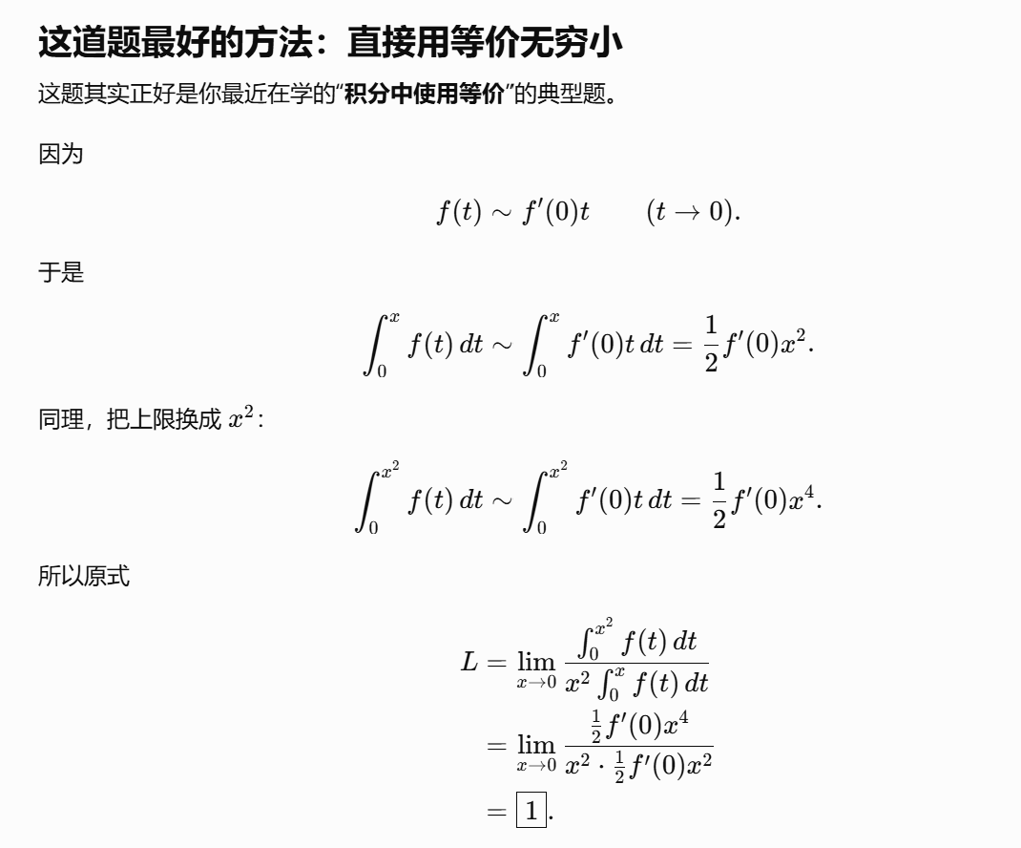
https://chatgpt.com/g/g-p-6a1d505226e08191a7f47eb8e9418ffe-gao-shu-ocr/c/6a76d41f-e03c-83ee-a8d9-bcd7c3a6c162

题6：
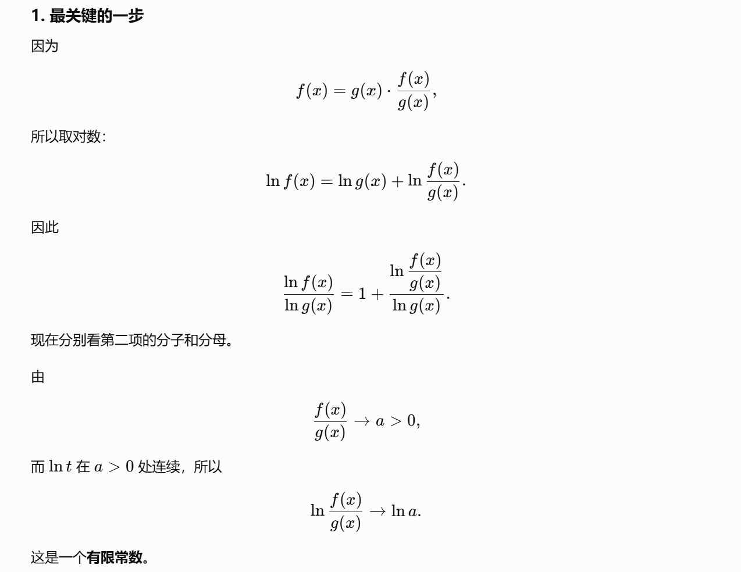
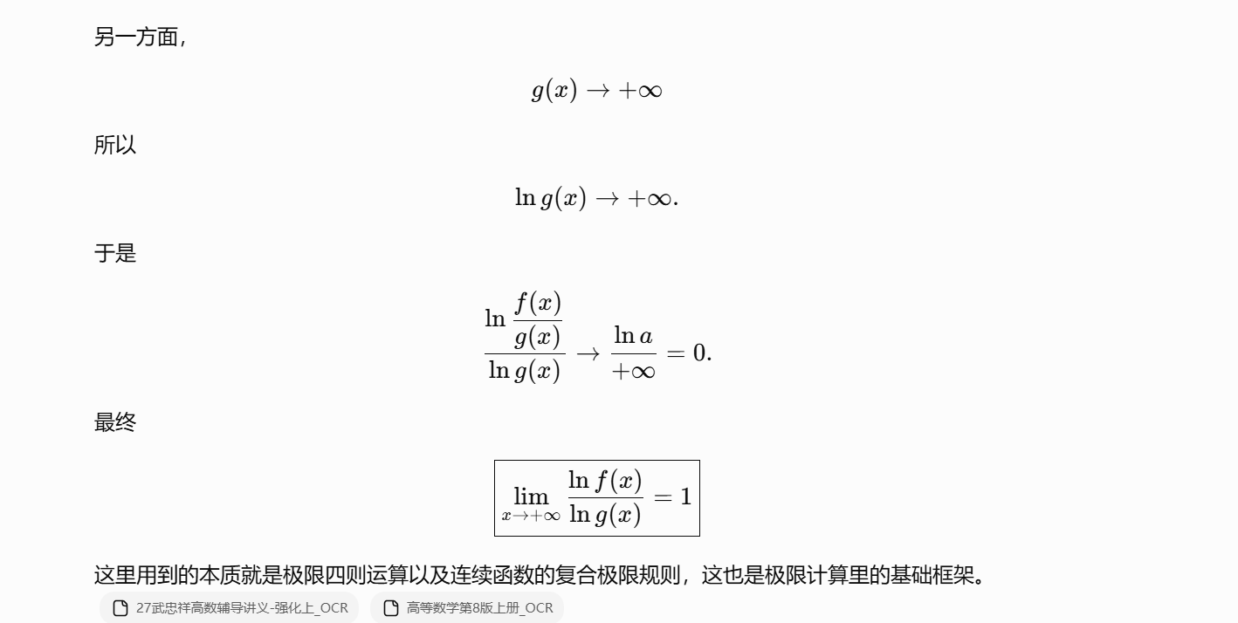
https://chatgpt.com/g/g-p-6a1d505226e08191a7f47eb8e9418ffe-gao-shu-ocr/c/6a76d62d-bef8-83ee-9403-2c214fca8903

题7：
https://chatgpt.com/g/g-p-6a1d505226e08191a7f47eb8e9418ffe-gao-shu-ocr/c/6a76d6a1-cd58-83ee-b313-414438b70d7a

题8：
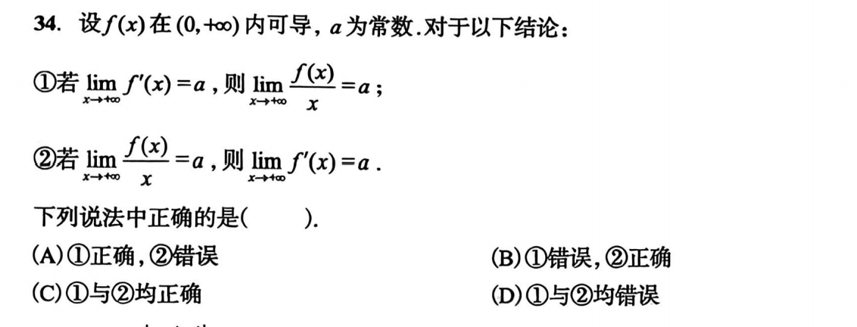
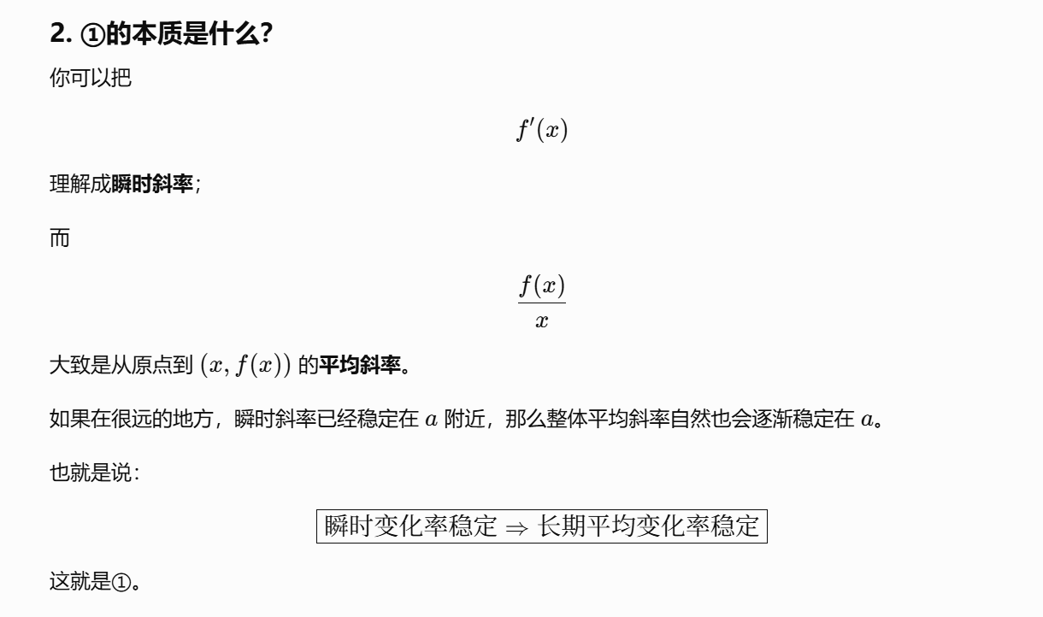
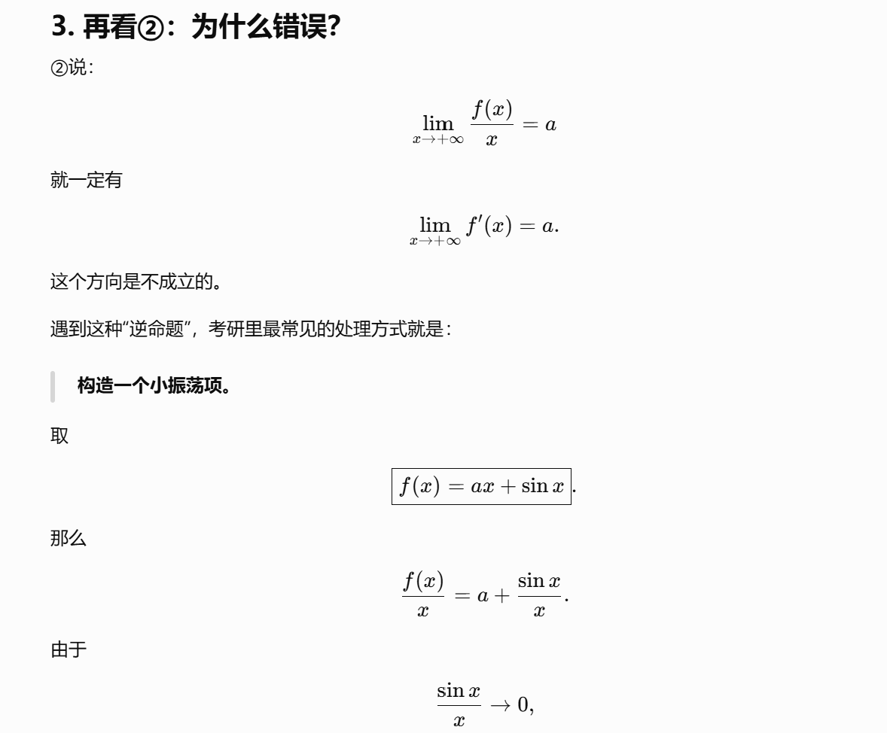
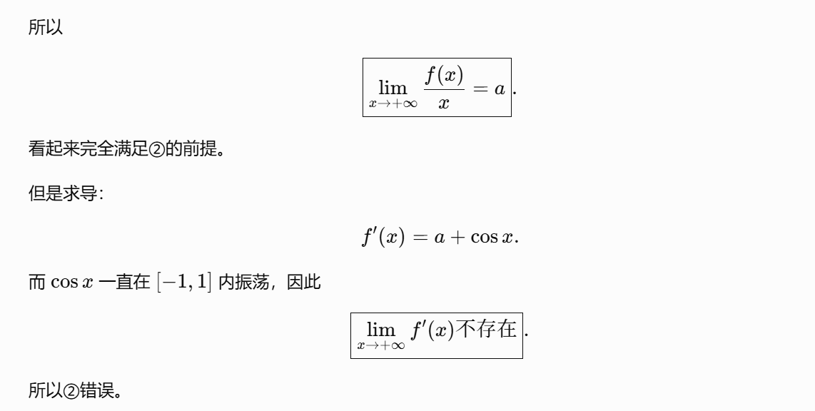
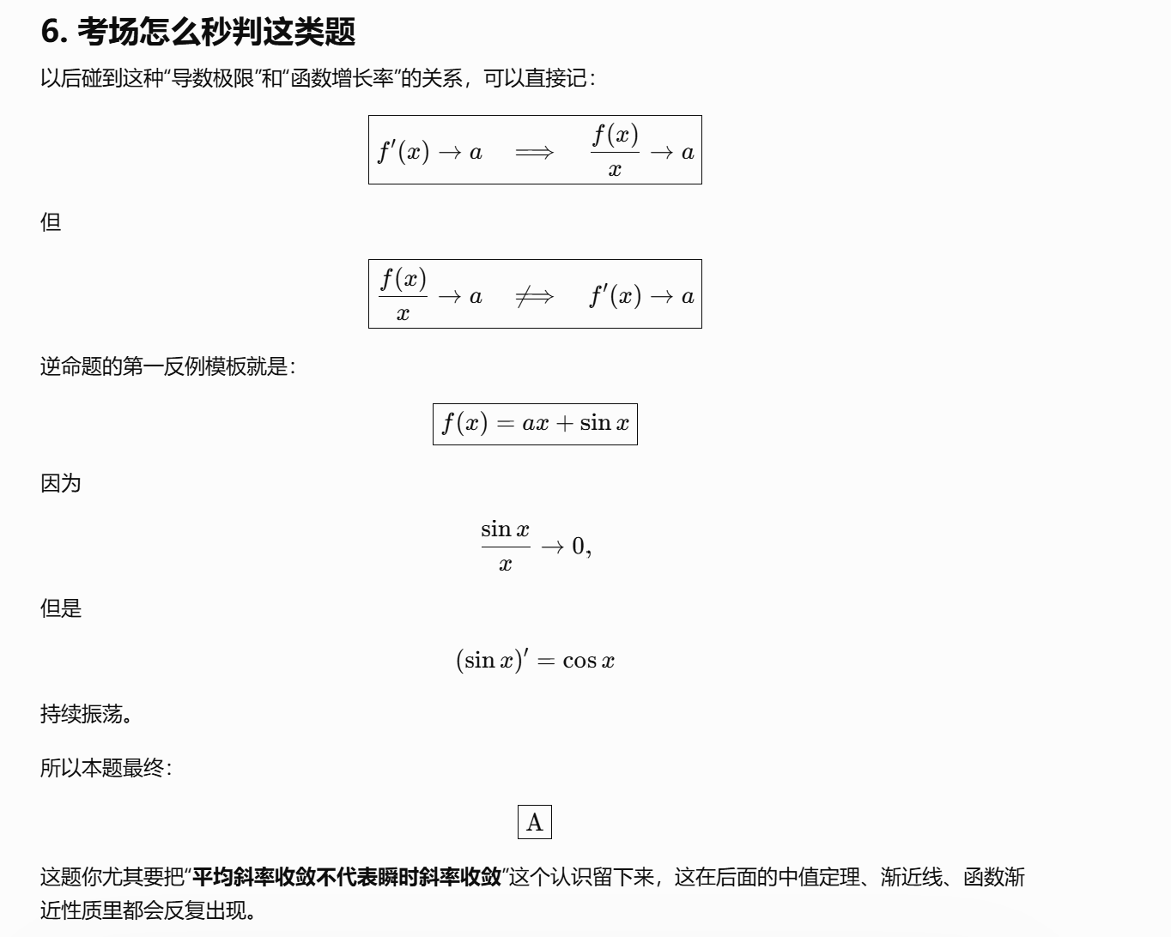
https://chatgpt.com/g/g-p-6a1d505226e08191a7f47eb8e9418ffe-gao-shu-ocr/c/6a76d6fb-fa68-83e9-82d2-acaf14361e45

题9：
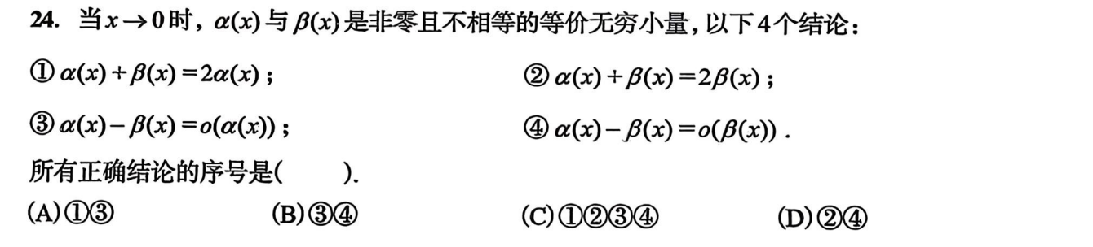
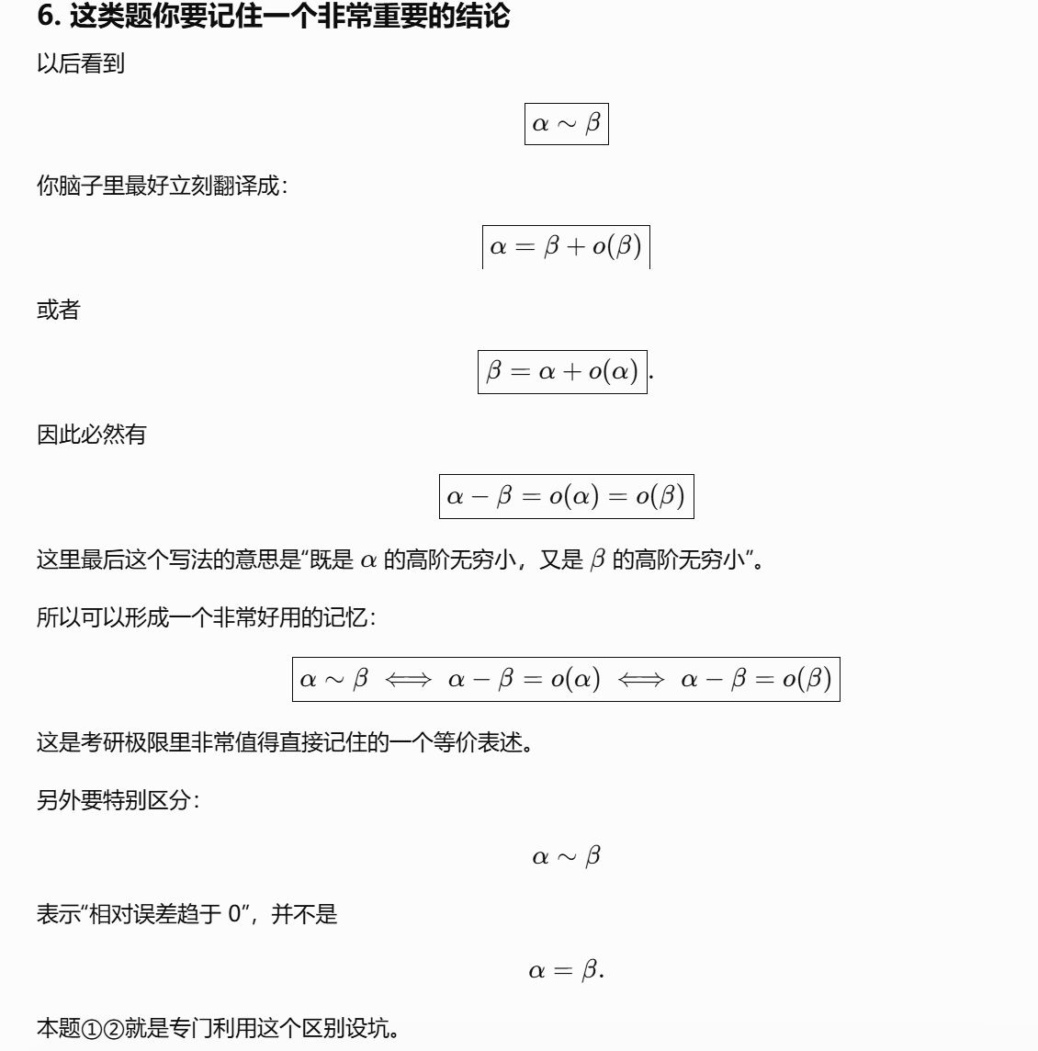
https://chatgpt.com/g/g-p-6a1d505226e08191a7f47eb8e9418ffe-gao-shu-ocr/c/6a76d979-4334-83e8-95ba-bd40f11b62d8
|（注：部分内容可能由 AI 生成）

